This document is merely to point out the differences in confessional count numbers between my findings and the official numbers posted on Survivor Sucks. The guidelines I use can be found [here](https://docs.google.com/document/d/18ofsPiVWxSejzSjEGlU8KEx4Og2ddEJScCV23RsCPIA/edit?usp=sharing).

**Survivor Sucks Season 24 Counts** ([link](https://goo.gl/photos/GqwvF3scPD9wTyTi9))

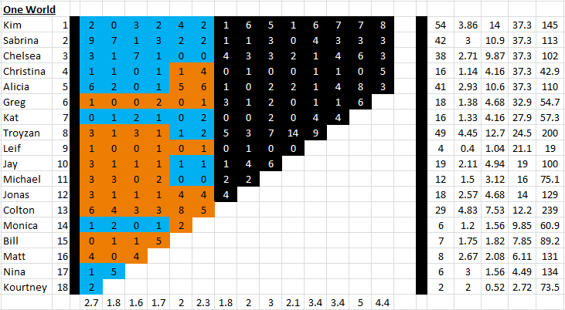

**My Season 24 Counts** ([link](https://goo.gl/photos/QmS9WLaBhWK63keP8))

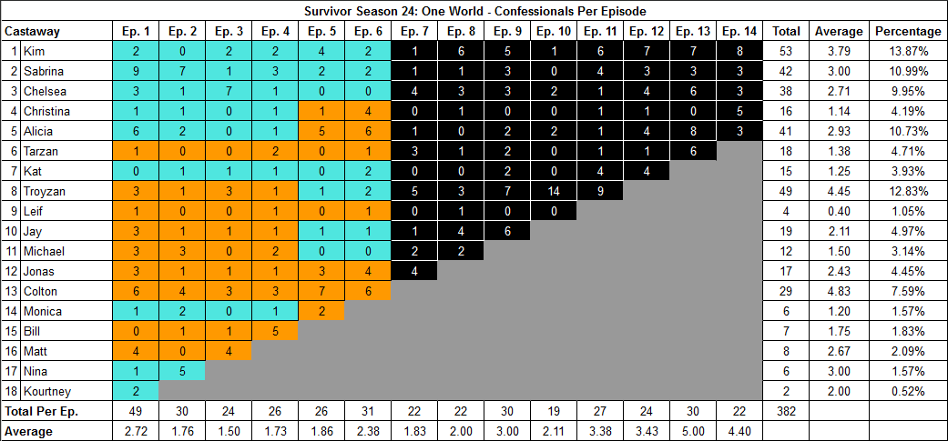

[Survivor Sucks Season 24 thread](http://survivorsucks.com/topic/91592).

**Differences**

[Episode 03](https://docs.google.com/document/d/1agRcooUrAnxHuZP-sC_QXhAVQAZFTA_XMcNNrgUVNrM/edit?usp=sharing)

* **Kim: 2 (-1)** Confessional #4 has a 9s gap.
* **Kat: 1 (-1)** Confessional #6 has a 9s gap.

[Episode 05](https://docs.google.com/document/d/1GcKg1WboTJmRQM50gPWv7xPLfBrFg9s2B0CpAfeRplk/edit?usp=sharing)

* **Jonas: 3 (-1)** Confessional #14 has a 9s gap.
* **Colton: 7 (-1)** I only counted 7 confessionals for Colton, not the established 8.
  + Day 12
    - Confessional #4: Time 10:39 - nuManono arrives at new camp.
    - Confessional #5: Time 11:09 - consecutive confessional with 14s gap.
    - Confessional #7: Time 11:53 - after talking to Alicia.
    - Confessional #8: Time 12:23 - consecutive confessional with 21s gap. After talking to Alicia and Christina.
  + Day 14
    - Confessional #18: Time 21:05 - After chicken gets loose.
    - Confessional #19: Time 22:11 - Consecutive confessional with 39s gap. After talking to Alicia on water.
    - Confessional #26: Time 33:25 - Last confessional pre-TC.

[Episode 06](https://docs.google.com/document/d/1JyMRweh-IClvNHbH_7_hR_pWwQNQ8euxdNBBXBtMvsY/edit?usp=sharing)

* **Colton: 6 (+1)** Between confessionals #20-21 there is a 13s gap, plus confessional #21 is a voice over.

**No Change**

* [Episode 01](https://docs.google.com/document/d/1Mrdy_86Es8cTXsqkGcHhJ4qLp8uFM-9q0LQuxxGoV0A/edit?usp=sharing)
* [Episode 02](https://docs.google.com/document/d/1G7gXFXVPKPb78PojH6hdr7RBEYCDgmI36xjTNVYwk5w/edit?usp=sharing)
* [Episode 04](https://docs.google.com/document/d/1Rdjfet31PF4t5owGBUQiAvX9zMw7jRgKHHGcTEuiXlE/edit?usp=sharing)
* [Episode 07](https://docs.google.com/document/d/1sl8oJ6idyLUmSuieXMUfdQWGT4ADhQ5DZfkXdVRCi5M/edit?usp=sharing)
* [Episode 08](https://docs.google.com/document/d/1YWaNbCEhUn5bPhxnCGYiNiEN8DNUL3fsugFnDyneEl0/edit?usp=sharing)
* [Episode 09](https://docs.google.com/document/d/1hhIx75O93omtbRteLbyd91xhsj4DTQrLHGYUOqb80R4/edit?usp=sharing) **Note:** Confessional #10 is an on-the-fly confessional where Tarzan narrates directly to the camera on the reward. This goes with the established count of 2 for him.
* [Episode 10](https://docs.google.com/document/d/1-Ymuq5pC204UlGJoeyo2Z0L-gIYHKT4EVs-YULrkUeY/edit?usp=sharing)
* [Episode 11](https://docs.google.com/document/d/1h6YXEVEhMPMf2jHYGt_i7jt_quDeypDO6ZJLfg_GqB4/edit?usp=sharing) **Note:** Confessional #16 is an on-the-fly Sabrina confessional where she is narrating to the camera (chyron on screen) and she gets interrupted by Christina while a pig is loose at camp. This goes with the established count of 4 for her.
* [Episode 12](https://docs.google.com/document/d/1sgvDaCRa92ctp_1cY_XelcZFJrYpw19ZIB-D5F_ZgT8/edit?usp=sharing)
* [Episode 13](https://docs.google.com/document/d/1-vZ6SR_dI985g-gWV4ERUyPuB8UqWmOSLIiyFv5FZGw/edit?usp=sharing)
* [Episode 14](https://docs.google.com/document/d/1-gbakZXzcP2E9GkywKI2FXTDwmu1zImaPMny0FyY0CY/edit?usp=sharing)

|  |  |  |
| --- | --- | --- |
| **Castaway** | **Count** | **Change** |
| Kim | 53 | -1 |
| Kat | 15 | -1 |
| Jonas | 17 | -1 |
| Colton | 29 | - |
| **Total** | **382** | **-3** |

**Revised Sucks Counts** ([link](https://goo.gl/photos/ssWYdAL3rwHaRkWP8))

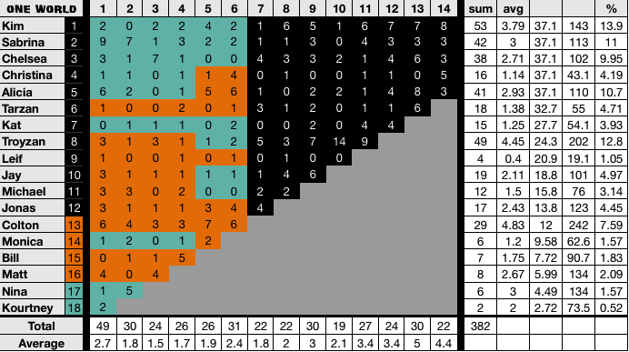

**Differences:** None. All my findings are reflected in the verified counts.